 Assignment 9

Name : Sahil Gujarathi
PRN : 1262252760
DIV : 1

Foundations of Programming
Assignment No. : 9

PROBLEM STATEMENT:
Write a program in C to check whether the given number is an Armstrong number or not.
An Armstrong number is an integer with three digits such that the sum of the cubes of its digits is equal to the number itself.
Example: 371

OBJECTIVE:
• To understand the concept of Armstrong numbers.
• To practice arithmetic operations in C.
• To develop logical thinking using loops and conditional statements.

THEORY:
An Armstrong number (also called a narcissistic number) is a number that is equal to the sum of the cubes of its digits. For a three-digit number abc, it is an Armstrong number if:
a³ + b³ + c³ = abc
For example, 371 is an Armstrong number because:
3³ + 7³ + 1³ = 27 + 343 + 1 = 371.

PLATFORM:

Linux

ALGORITHM:
- Start
- Read a three-digit number num
- Initialize sum = 0 and store original number in originalNum
- Repeat until num != 0
- Extract last digit: digit = num % 10
- Add cube of digit to sum: sum = sum + digit^3
- Remove last digit: num = num / 10
- If sum == originalNum, then number is Armstrong
- Else, number is not Armstrong
- End

C PROGRAM:
#include <stdio.h>
#include <math.h>

int main() {
int num, originalNum, remainder, sum = 0;

// Input a number
printf("Enter a three-digit number: ");
scanf("%d", &num);

originalNum = num;

// Calculate sum of cubes of digits
while (num != 0) {
remainder = num % 10; // Extract last digit
sum += remainder * remainder * remainder; // Cube it and add to sum
num /= 10; // Remove last digit
}

// Check if sum equals original number
if (sum == originalNum)
printf("%d is an Armstrong number.\n", originalNum);
else
printf("%d is not an Armstrong number.\n", originalNum);

return 0;
}
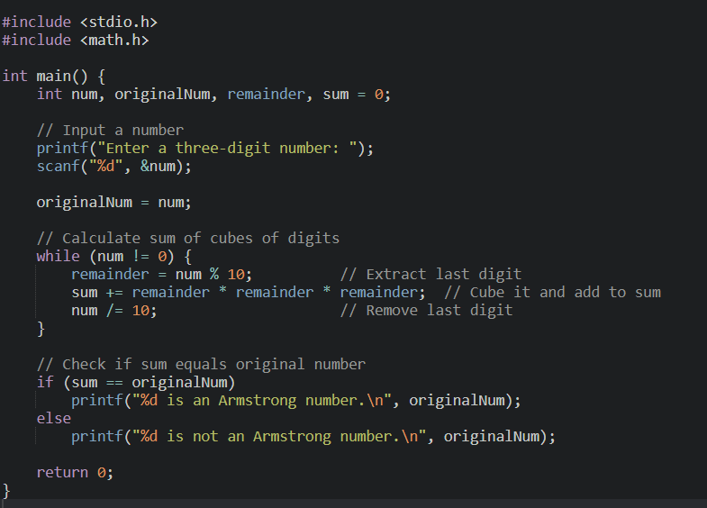

INPUT:
Enter a three-digit number. 371
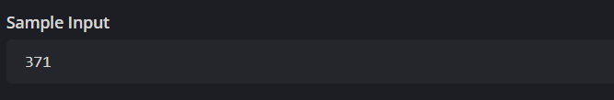

OUTPUT:
Enter a three-digit number: 371
371 is an Armstrong number.
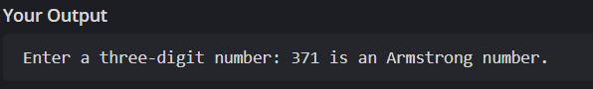

CONCLUSION:
Thus, we have successfully written a C program to check whether a given number is an Armstrong number using loops and arithmetic operations.

FAQs:
1. What is an Armstrong number?
2. Why is the Armstrong number concept important in programming?
3. How does this program work step by step?

